**How to convert MVC View to PDF using C# in ASP.NET Core**

The Syncfusion® [**HTML to PDF converter**](https://www.syncfusion.com/document-processing/pdf-framework/net/html-to-pdf) is a .NET library for converting webpages, SVG, MHTML, and HTML to PDF using C#. It is reliable and accurate. The result preserves all graphics, images, texts, fonts, and the layout of the original HTML document or webpage.

Using this library, you can convert MVC view to a PDF document using C# in [**ASP.NET**](http://asp.net/) Core.

**Steps to convert the MVC view to PDF document programmatically:**

1.Create a new [ASP.NET Core](http://asp.net/) Web application project.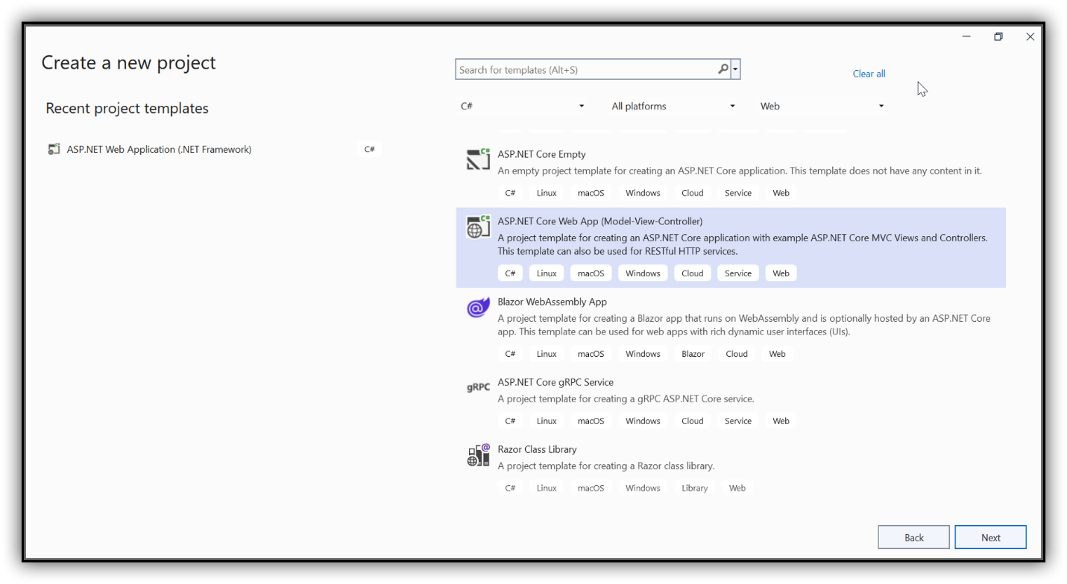

2.Name your project in the configuration window and click Next.

3. **Install Required Packages**: Add the [Syncfusion.HtmlToPdfConverter.Net.Windows](https://www.nuget.org/packages/Syncfusion.HtmlToPdfConverter.Net.Windows) NuGet package to your application from [NuGet.org](https://www.nuget.org/).

4. **Set Up Your Controller**: The default controller, **HomeController.cs**, is included in your project. Ensure these namespaces are present  
C#

|  |
| --- |
| using Syncfusion.HtmlConverter;  using Syncfusion.Pdf; |

5. **Add Conversion Button in View**: Insert a button in **index.cshtml** to trigger the PDF conversion  
C#

|  |
| --- |
| @Html.BeginForm("ConvertToPDF", "Home", FormMethod.Post)  {  <h2><input type="submit" value="Convert To PDF"></h2>  } |

6. **Implement Conversion Logic in Controller**: Use the following code in **HomeController.cs** to convert your MVC View to a PDF  
C#

|  |
| --- |
| public async Task<IActionResult> ConvertToPDF()  {  // Convert Index view to HTML  string html = await ViewToStringAsync(this, "Index", null);  string baseUrl = string.Empty;    // Initialize HTML to PDF converter  HtmlToPdfConverter htmlConverter = new HtmlToPdfConverter();    // Convert HTML string to PDF  PdfDocument document = htmlConverter.Convert(html, baseUrl);    // Create memory stream  MemoryStream stream = new MemoryStream();    // Save and close the PDF document  document.Save(stream);  document.Close(true);    return File(stream.ToArray(), "application/pdf", "ViewAsPdf.pdf");  } |

A complete working sample can be downloaded from [**MVC_ViewToPDF.Zip**](https://www.syncfusion.com/downloads/support/directtrac/general/ze/MVC_ViewToPDF_11605711822).

By executing the program, the output PDF document will be generated as shown below:

Take a moment to explore the [documentation](https://help.syncfusion.com/file-formats/pdf/converting-html-to-pdf), where you’ll find detailed information on converting HTML pages to PDF documents, along with available customization options and features.

**Note:** Starting from version 16.2.0.x, if you reference Syncfusion® assemblies from the trial setup or NuGet feed, you must include a valid license key in your projects. Refer to the linked guide for instructions on how to generate and register the Syncfusion® license key in your application to use the components without displaying a trial message.

**Conclusion**  
I hope you enjoyed learning about how to convert MVC View to PDF using C# in [**ASP.NET**](http://asp.net/) Core.

You can refer to our [**ASP.NET MVC PDF feature tour**](https://www.syncfusion.com/document-processing/pdf-framework/net) page to know about its other groundbreaking feature representations and documentation, and how to quickly get started for configuration specifications. You can also explore our [**ASP.NET MVC PDF Example**](https://www.syncfusion.com/demos/fileformats/pdf-library) to understand how to create and manipulate data.

For current customers, you can check out our [**ASP.NET**](http://asp.net/) Core Components from the [**License and Downloads**](https://www.syncfusion.com/sales/teamlicense) page. If you are new to Syncfusion®, you can try our 30-day [**free trial**](https://www.syncfusion.com/downloads/aspnetmvc-js2) to check out our other controls.

If you have any queries or require clarifications, please let us know in the comments section below. You can also contact us through our [**support forums**](https://www.syncfusion.com/forums), [**Direct-Trac**](https://support.syncfusion.com/create), or [**feedback portal**](https://www.syncfusion.com/feedback/aspnet-mvc?control=pdf). We are always happy to assist you!